Session 16
Entry Planning Sheet
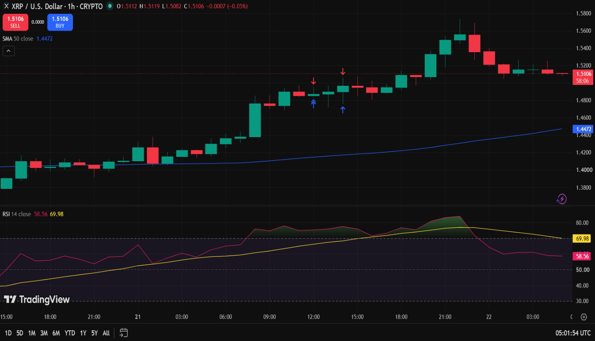
Observation | Sample Finding
Asset | XRPUSD
Timeframe | 1 Hour
Price Position | Above 50 SMA
SMA Direction | UPWARD
RSI Value | 58.77
RSI Zone | Neutral
Near Support | NO
Near Resistance | YES
Recent Candlestick | Bullish
Final Decision | Continuous observing
Reason | Although the overall trend remains bullish with price above an upward-sloping 50 SMA and a neutral RSI of 58.56, the asset is currently testing a known resistance level following a recent local high near 1.5800.

Session 17
Exit Planning Sheet
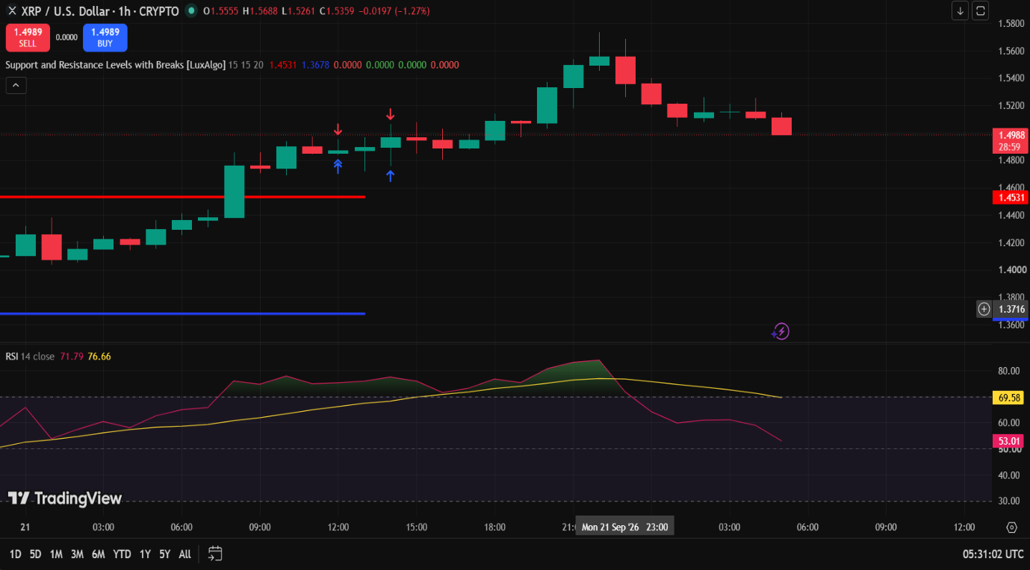
Observation | Sample Finding
Asset | XRPUSD
Timeframe | 1 Hour
Current Trade | Long
Price Near Support / Resistance | Yes, near Resistance
RSI Value | 61.68
RSI Observation | neutral
Candlestick | Bullish candle near Resistance
Final Decision | Hold
Reason | Although price is approaching a major resistance zone near 1.5800, continuing to hold the long position is justified because the broader structural trend remains firmly bullish. The RSI at 61.68 sits in a healthy neutral expansion territory, showing strong upward momentum without yet being overextended.

Session 18
Trading Plan Review and Execution Report

Field | Details
Asset | XRPUSD
Timeframe | 1 Hour
Trade Position | HOLD
Original Entry Plan | Near Resistance
Original Exit Plan | Near Resistance
Were Current Market Conditions Different from the Original Plan? | Yes
Were Any Revisions Made? | Yes
If Yes, Describe the Revisions | Entry was not taken; the trade was kept on hold and the market was observed for further confirmation.
Reason for the Revision | The market conditions did not provide sufficient confirmation for the planned trade, so entering the position was avoided.
Final Trading Decision | Continued Observing
Trade Status | No Trade Executed
Was the Trading Plan Followed? | Yes
Outcome (if executed) | Loss
Key Learning | Do not enter a trade without sufficient confirmation. If market conditions change from the original plan, wait and observe rather than forcing a trade.

